lo |  | Marttell Sánchez  July 24, 2022  Message #17 / Hosea
 |  | newlifeukiah.com/sermons
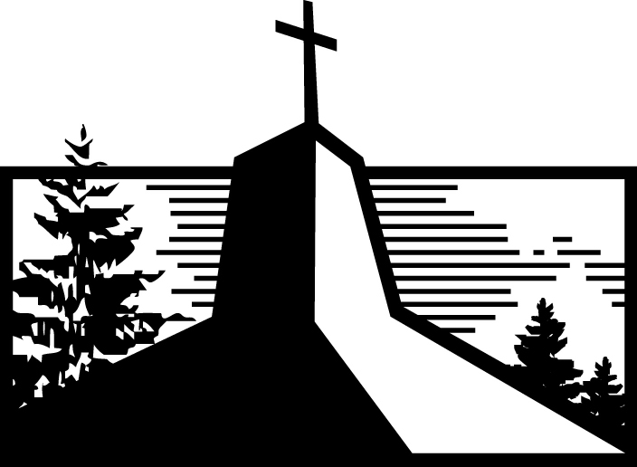
A History Lesson Part 1
Hosea 11:12-12:6

Learning from Jacob

- Jacob was a _______________ and a _______________, and so were his _______________.
(11:12; 12:1, 3a)

- God had a charge against Jacob, but Jacob _______________ God for his _______________.
(12:2, 3b-6)

THE LESSON → You are who you are _______________ by God’s _______________.

Living by God’s Grace Today

- Don’t _______________ for the _______________ message.

- Grasping at _______________ is the _______________.

- If you’ve _______________ grace, _______________ grace.

4:8-9
Marttell Sánchez
July 24, 2022
Message #17 / Hosea
newlifeukiah.com/sermons
A History Lesson Part 1
Hosea 11:12-12:6

Learning from Jacob

- Jacob was a GRASPER and a DECEIVER, and so were his DESCENDANTS.
(11:12; 12:1, 3a)

- God had a charge against Jacob, but Jacob BEGGED God for his GRACE.
(12:2, 3b-6)

THE LESSON → You are who you are ENTIRELY by God’s GRACE.

Living by God’s Grace Today

- Don’t FALL for the CULTURAL message.

- Grasping at GOD is the KEY.

- If you’ve RECEIVED grace, GIVE grace.

For Further Study
_________________________________________________________________________________________________
Getting Started
- What lesson(s) stood out to you this week from the story of Jacob?

Digging Deeper
- Hosea 12:4 states that Jacob “wrestled” with God; he “wept and begged for his favor.”

- What does it mean to “wrestle” with God for his grace?

- In what practical way(s) can you “wrestle” with God and beg him for his grace today?

- Hosea 12:4 also highlights that Jacob “overcame” God for his grace.

- What does God do so he could bless Jacob?

- What has God done so he could bless us?

- What does this teach you about God?

Driving It Home
- As you become the kind of person that continually grasps at God, what results and changes can you expect in your life?

