lo |  | Marttell Sánchez  April 3, 2022  Message #6 / Hosea
 |  | newlifeukiah.com/sermons
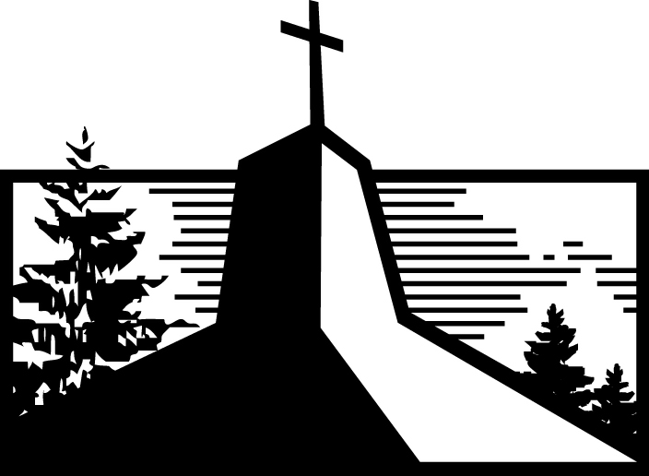
Why We Need the Good Shepherd
Hosea 4:1-19

Israel’s Courtroom Scene

- THE CHARGES No ____________________, no __________, no ____________________.

- THE VERDICT Nothing but ____________________ and ____________________.

What We Need

- To __________ God.

- A good ____________________ who will ____________________ us.

Learning from Israel’s Court Case

- We can’t ____________________ God and expect to keep his ____________________.

- A breakdown in our relationship with __________ leads to a breakdown in our relationships with ____________________.

- There is a difference between _______________ accusations and speaking the truth in __________.

- We can know ____________________ God through several avenues, but the only way to know him ____________________ is through Christ.

- God does everything to change us from ____________________ cows to _______________ lambs.

4:8-9
Marttell Sánchez
April 3, 2022
Message #6 / Hosea
newlifeukiah.com/sermons
Why We Need the Good Shepherd
Hosea 4:1-19

Israel’s Courtroom Scene

- THE CHARGES No FAITHFULNESS, no LOVE, no KNOWLEDGE.

- THE VERDICT Nothing but BROKENNESS and MOURNING.

What We Need

- To KNOW God.

- A good SHEPHERD who will TRANSFORM us.

Learning from Israel’s Court Case

- We can’t DESERT God and expect to keep his BLESSINGS.

- A breakdown in our relationship with GOD leads to a breakdown in our relationships with ONE ANOTHER.

- There is a difference between HYPOCRITICAL accusations and speaking the truth in LOVE.

- We can know ABOUT God through several avenues, but the only way to know him INTIMATELY is through Christ.

- God does everything to change us from STUBBORN cows to DOCILE lambs.
For Further Study
_________________________________________________________________________________________________
Getting Started
- God’s main accusation is “no faithfulness, no love, no knowledge of God” (Hosea 4:1). What signs of this do we see in today’s society?

- What signs of this do we see in the modern church?

Digging Deeper
- Hosea 4:2-3 shows that a breakdown in our relationship with God inevitably leads to a breakdown in our relationships with others and creation. What signs of this do we see today?

- Why does “knowing God” make all the difference in our level of love and faithfulness?

Driving It Home
- What is one practical step you’d like to take this week toward knowing God better?

- Is there any “stubbornness” that you’d like to give up to Jesus? Spend some time in prayer petitioning the good Shepherd to bring change into your heart.

