lo |  | Marttell Sánchez  July 3, 2022  Message #16 / Hosea
 |  | newlifeukiah.com/sermons
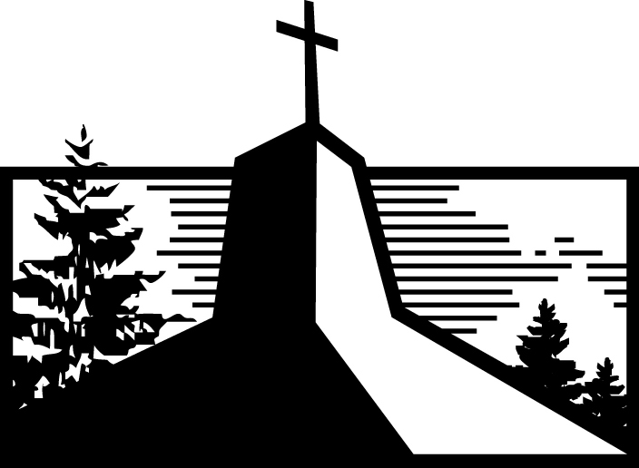
Seeing the Father’s Tenderness
Hosea 11:1-11

Learning from the Tenderest of Illustrations

- See the Father’s ____________________ heart. (Verses 1-4)

- See the Father’s ____________________ heart. (Verses 5-7)

- See the Father’s ____________________ heart. (Verses 8-11)

THE POINT → God does not _______________ like __________ do.

Lessons for Today

- How you _______________ God makes all the difference in whether you run _______________ him or _______________ him.

REMEMBER → The more you _______________ God’s _______________, the less you’ll ____________________ from him.

- There is nothing you can do to make God _______________ you any _______________.

REMEMBER → God doesn’t _______________ us like Admah and Zeboyim because Jesus was ____________________ like them in _________________________.

4:8-9
Marttell Sánchez
June 19, 2022
Message #15 / Hosea
newlifeukiah.com/sermons
Seeing the Father’s Tenderness
Hosea 11:1-11

Learning from the Tenderest of Illustrations

- See the Father’s CARING heart. (Verses 1-4)

- See the Father’s CRUSHED heart. (Verses 5-7)

- See the Father’s COMPASSIONATE heart. (Verses 8-11)

THE POINT → God does not LOVE like WE do.

Lessons for Today

- How you VIEW God makes all the difference in whether you run FROM him or TO him.

REMEMBER → The more you TRUST God’s GRACE, the less you’ll TURN AWAY from him.

- There is nothing you can do to make God LOVE you any LESS.

REMEMBER → God doesn’t TREAT us like Admah and Zeboyim because Jesus was TREATED like them in OUR PLACE.
For Further Study
_________________________________________________________________________________________________
Getting Started
- In what ways does the tender illustration in Hosea 11 help you understand God’s relationship with his people?

Digging Deeper
- What do the following passages teach you about God’s love for his people?

- John 14:15-24

- John 15:9, 13

- Romans 8:35-39

- How do the following passages strengthen your view of God as a tender Father?

- Luke 15:11-24

- Romans 8:14-16

- Hebrews 4:14-16

Driving It Home
- In what ways has Hosea 11 impacted your desire to run towards God rather than away from him? What one thing can you do this week to get closer to your loving Father in heaven?

